Anytime Menu
Availability May Vary

Bruschetta - $5
Crostini topped with Mozzarella cheese, herbed tomatoes, and balsamic vinegar
Bread Basket - $6
When all you need is a little bread. Served with Olive Oil and Parmesan Cheese
Bob’s Famous Smoked Salmon Spread - $11
House-smoked Atlantic Salmon blended with Cream Cheese and 11 secret herbs and spices. Served with baguette
Michigan Chicken Salad Wrap - $10
Roasted chicken salad with dried cherries and basil
The Vineyard Platter - $16
A selection of meats and cheeses paired with assorted antipasti, served with bread, oil, and Parmesan

Watch Digital Sign for Weekly Specials

Join our Loyalty Club at checkout to earn valuable points on purchases
Let’s Stay in Touch 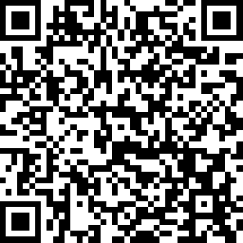
If we don’t have your email address we can’t send you news, special invitations, or special coupons.

Grill Menu
Friday and Saturday, 5-8 PM

Hamburger Menu

Hamburger 1/3# - $12
Add cheese, Provolone or American- $1
Add bacon - $1

Skirt Burger 1/2# - $14
Two ¼# patties with a grilled cheese skirt

Add your own tomato, ketchup, mustard, mayo, lettuce, onion, pickle
All burgers are cooked to order, please be patient

**Notice: Consuming raw or undercooked meats, poultry, seafood, shellfish, or eggs may increase your risk of foodborne illness

